Nama : Afridho Ikhsan

Kelas : 3A-Informatika

NPM : 2210631170002

Mata Kuliah : Pemrograman Berorientasi Objek (PBO)

Buatlah program seperti berikut :

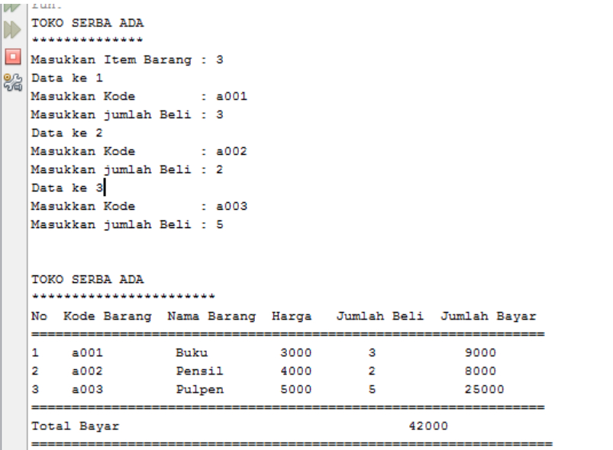

Dengan Ketentuan :

a. Inputan :

Item Barang, Kode, dan Jumlah Beli

b. Output :

Seperti tampilan diatas

c. Penentuan Nama Barang serta Harga Berdasarkan Kode Baran

* Class Item

|  |  |
| --- | --- |
|  | public class Item { |
|  | String kodeBarang; |
|  | String namaBarang; |
|  | int hargaBarang; |
|  |  |
|  | public Item(String kodeBarang, String namaBarang, int hargaBarang) { |
|  | this.kodeBarang = kodeBarang; |
|  | this.namaBarang = namaBarang; |
|  | this.hargaBarang = hargaBarang; |
|  |  |
|  | } |
|  | } |

* Class TokoSerbaAda

|  |  |
| --- | --- |
|  | import java.util.Scanner; |
|  |  |
|  | public class TokoSerbaAda { |
|  | static public void main(String[] args) { |
|  | Scanner masukkan = new Scanner(System.in); |
|  |  |
|  | Item[] daftarBarang = { new Item("a001", "Buku", 3000), new Item("a002", "Pensil", 4000), new Item("a003", "Pulpen", 5000) }; |
|  |  |
|  | String[] kodeYangDipilih = new String[3]; |
|  | int[] jumlahBeliPerBarang = new int[3]; |
|  | int totalBayar = 0; |
|  |  |
|  | System.out.println("Toko Serba Ada"); |
|  | System.out.println("******************"); |
|  |  |
|  | System.out.print("Masukkan Item Barang: "); |
|  | int jumlahBarangYangDibeli = masukkan.nextInt(); |
|  |  |
|  | for (int i = 0; i < jumlahBarangYangDibeli; i++) { |
|  | System.out.println("Data ke " + (i + 1)); |
|  |  |
|  | System.out.print("Masukkan kode: "); |
|  | masukkan.nextLine(); |
|  | kodeYangDipilih[i] = masukkan.nextLine(); |
|  |  |
|  | System.out.print("Masukkan jumlah beli: "); |
|  | jumlahBeliPerBarang[i] = masukkan.nextInt(); |
|  | } |
|  |  |
|  | System.out.println("Toko Serba Ada"); |
|  | System.out.println("******************"); |
|  |  |
|  | System.out.println("No\tKode Barang\tNama Barang\tHarga\tJumlah Beli\tJumlah Bayar"); |
|  | System.out.println("===================================================================================="); |
|  | for (int j = 0; j < jumlahBarangYangDibeli; j++) { |
|  | int indexBarang = 0; |
|  | for (int k = 0; k < daftarBarang.length; k++) { |
|  | if (daftarBarang[k].kodeBarang.equals(kodeYangDipilih[j])) { |
|  | indexBarang = k; |
|  | break; |
|  | } |
|  | } |
|  |  |
|  | int totalBayarPerBarang = (jumlahBeliPerBarang[j] * daftarBarang[indexBarang].hargaBarang); |
|  |  |
|  | System.out.println((j + 1) + ".\t" + kodeYangDipilih[j] + "\t\t" + daftarBarang[indexBarang].namaBarang+ "\t\t" + daftarBarang[indexBarang].hargaBarang + "\t" + jumlahBeliPerBarang[j] + "\t\t"+ totalBayarPerBarang); |
|  |  |
|  | totalBayar += totalBayarPerBarang; |
|  | } |
|  | System.out.println("===================================================================================="); |
|  | System.out.println("Total Bayar\t\t" + totalBayar); |
|  | System.out.println("===================================================================================="); |
|  | } |
|  | } |

Output TokoSerbaAda:

